# **Lab Assignment- 4.4**

**AI Assisted Coding**

**E Srivarsha**

**HTno– 2303A52343**

Problem Statement:

1. Sentiment Classification for Customer Reviews

Scenario: An e-commerce platform wants to analyze customer reviews and classify them into Positive, Negative, or Neutral sentiments using prompt engineering.

Tasks:

1. Prepare 6 short customer reviews mapped to sentiment labels.

b) Design a Zero-shot prompt to classify sentiment.

c) Design a One-shot prompt with one labeled example.

d) Design a Few-shot prompt with 3–5 labeled examples.

e) Compare the outputs and discuss accuracy differences

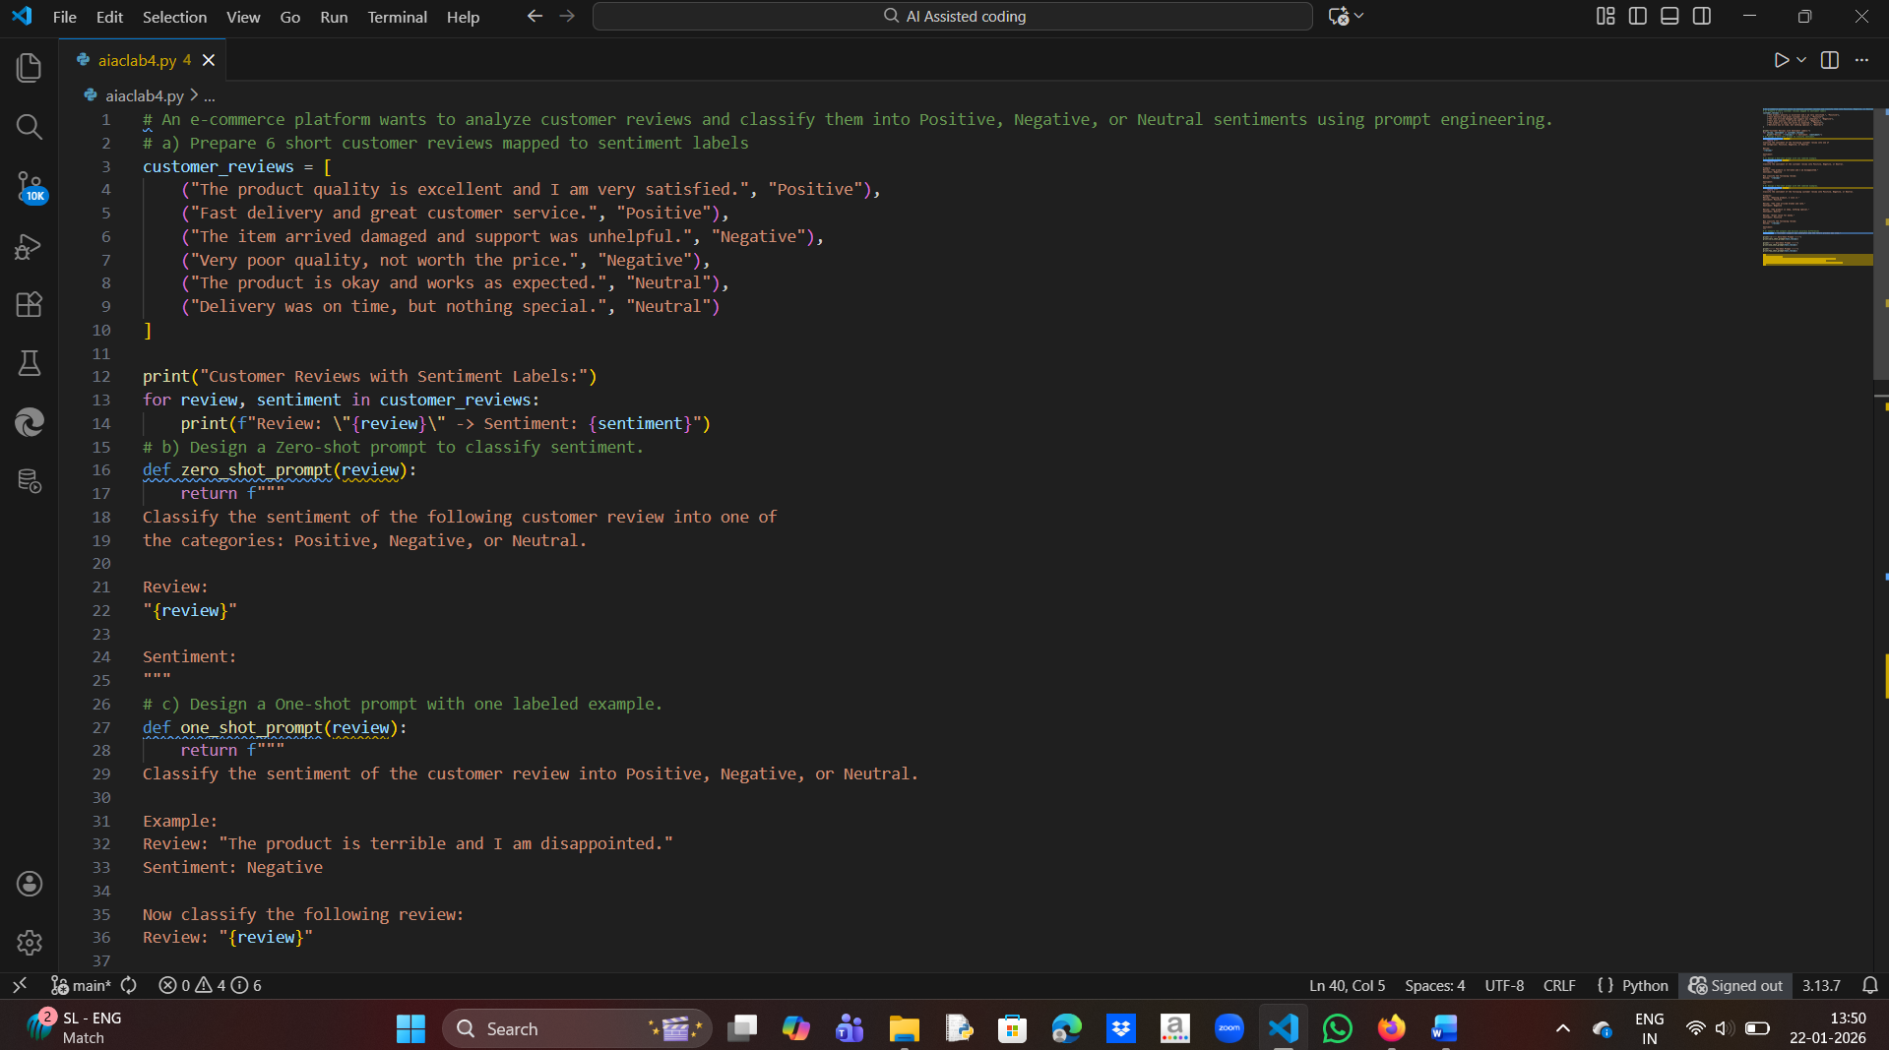

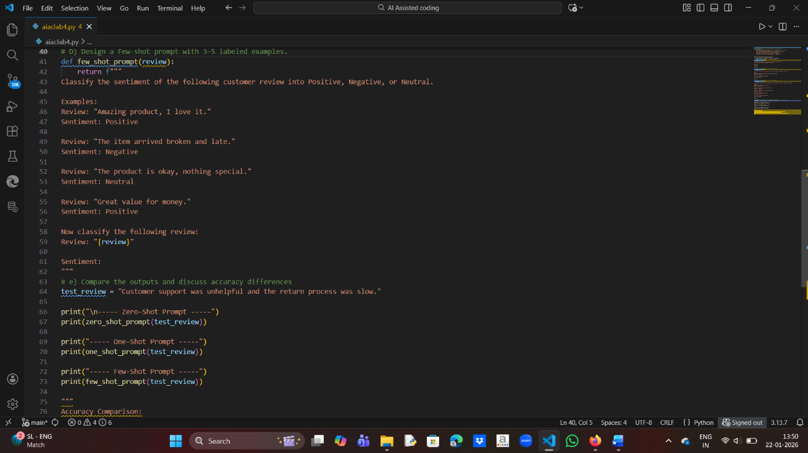

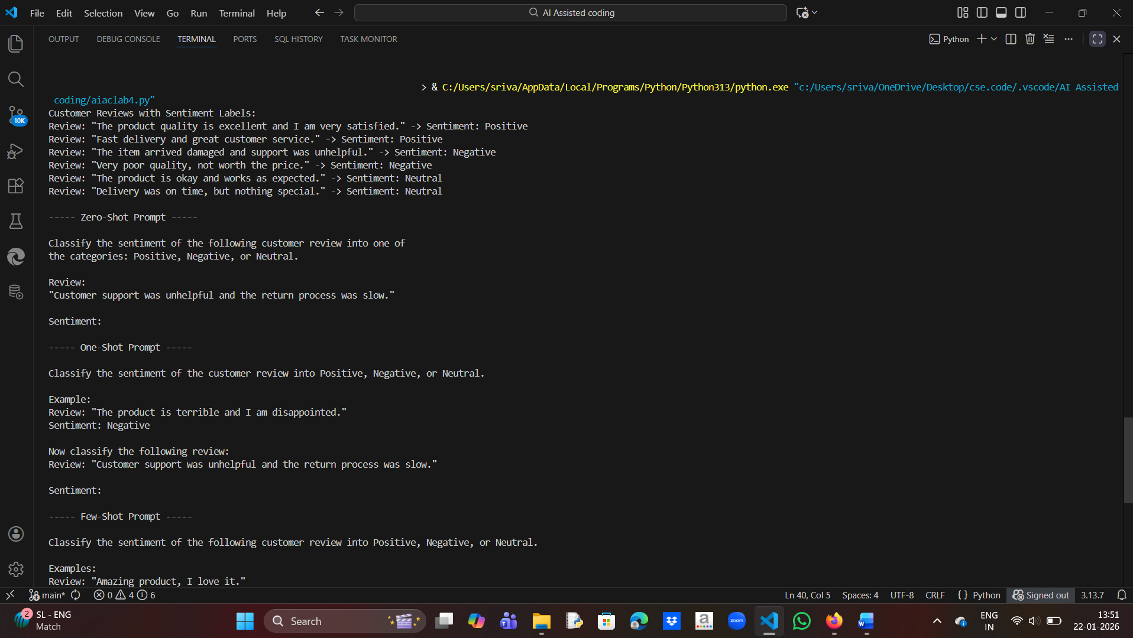

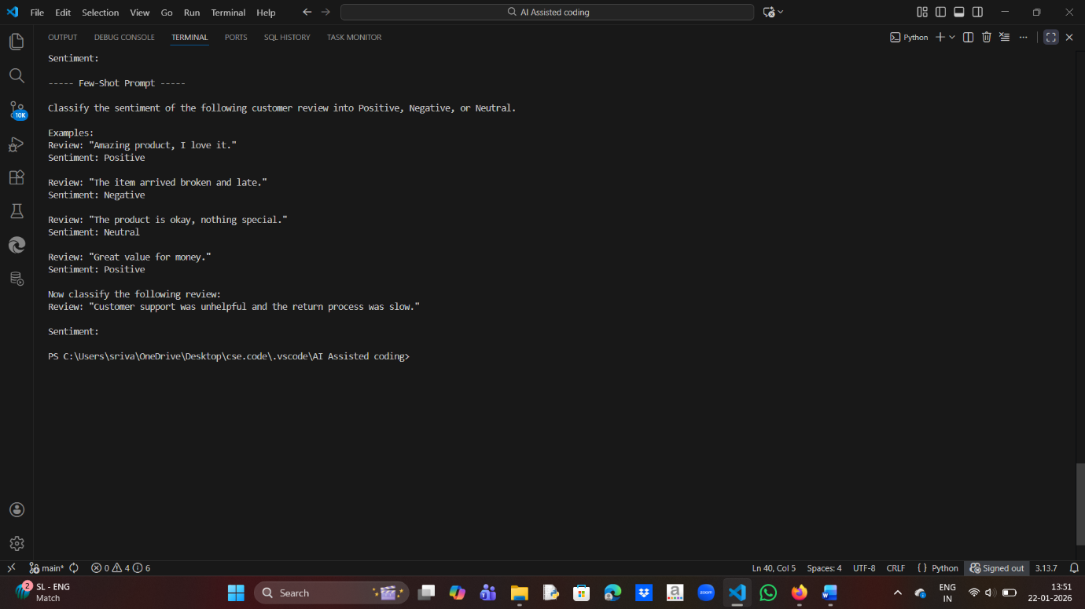

Accuracy Comparison:

- Zero-shot prompt gives moderate accuracy and may fail for mixed reviews.

- One-shot prompt improves understanding using a single example.

- Few-shot prompt provides the highest accuracy due to multiple labeled examples.

2. Email Priority Classification

Scenario:

A company wants to automatically prioritize incoming emails into HighPriority, Medium Priority, or Low Priority.

Tasks:

1. Create 6 sample email messages with priority labels.

2. Perform intent classification using Zero-shot prompting.

3. Perform classification using One-shot prompting.

4. Perform classification using Few-shot prompting.

5. Evaluate which technique produces the most reliable results and why.

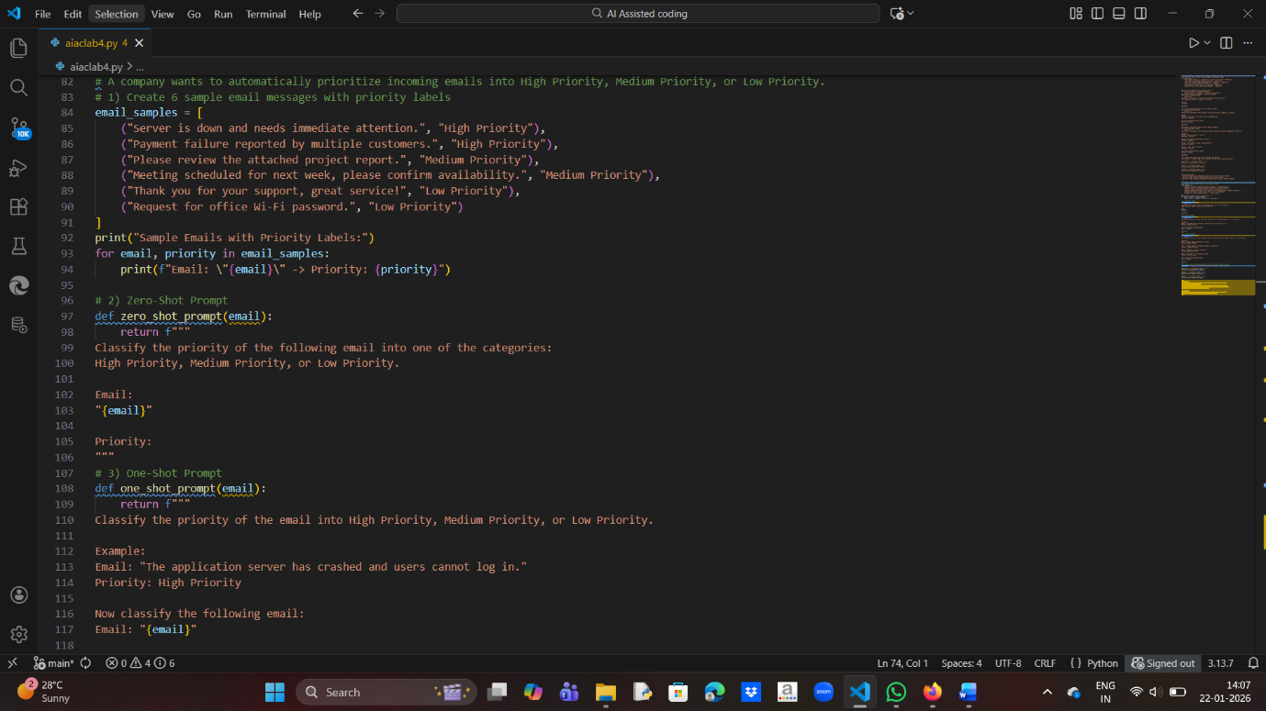

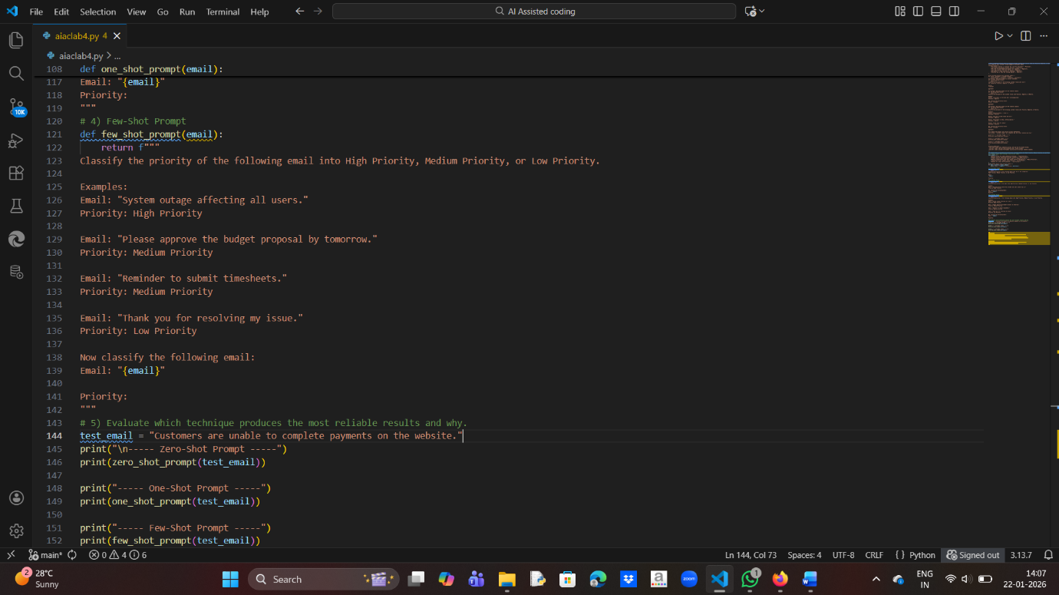

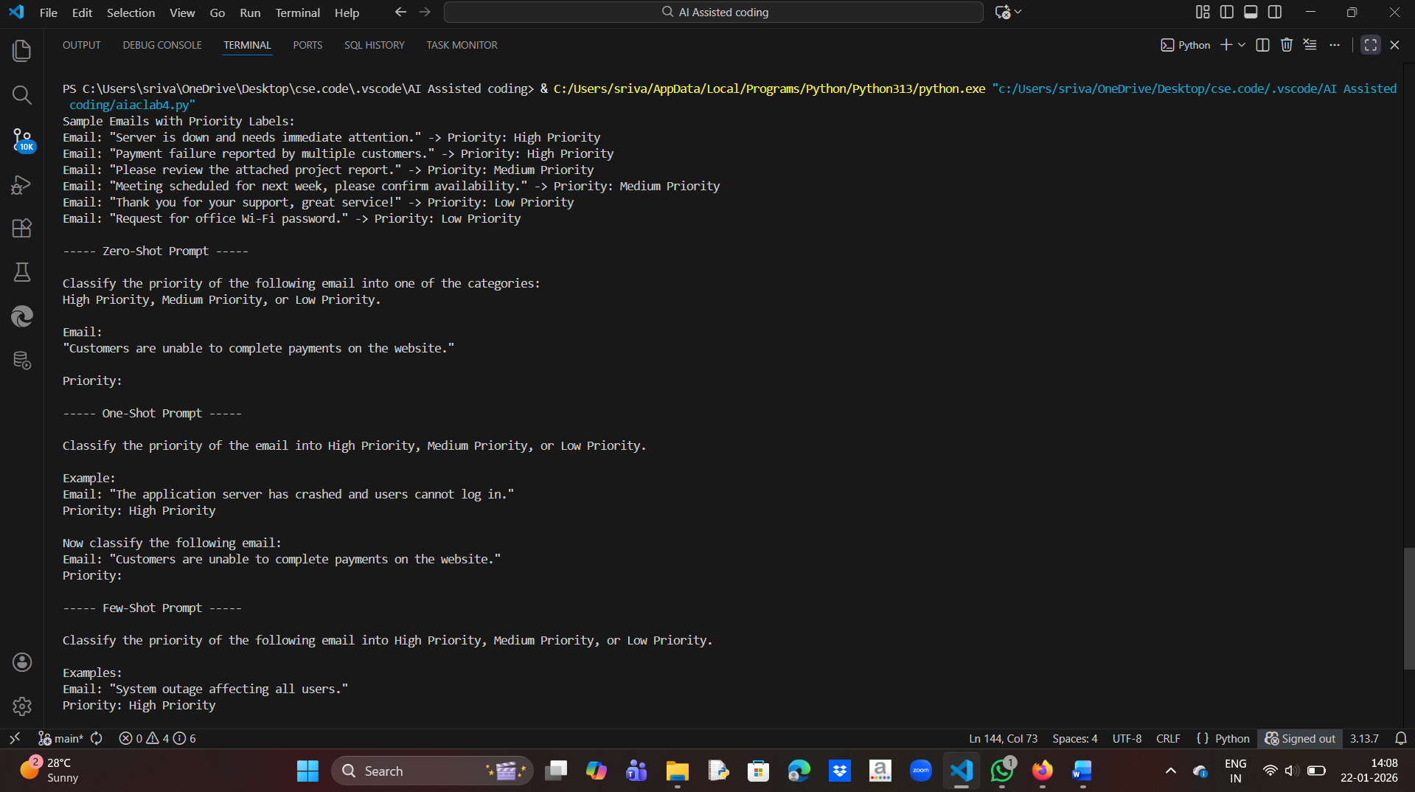

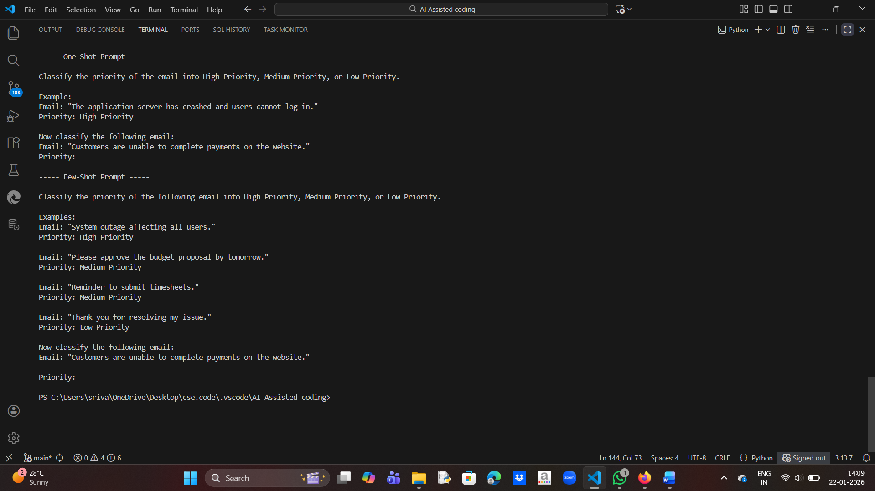

Evaluation:

- Zero-shot prompting provides moderate accuracy but may misclassify emails with unclear urgency.

- One-shot prompting improves accuracy by showing one labeled example.

- Few-shot prompting produces the most reliable results because multiple

  examples clearly define priority levels.

Conclusion:

Few-shot prompting is the most effective technique for email priority

classification due to better contextual understanding.

3. Student Query Routing System

Scenario:

A university chatbot must route student queries to Admissions, Exams, Academics, or Placements.

Tasks:

1. Create 6 sample student queries mapped to departments.

2. Implement Zero-shot intent classification using an LLM.

3. Improve results using One-shot prompting.

4. Further refine results using Few-shot prompting.

5. Analyze how contextual examples affect classification accuracy.

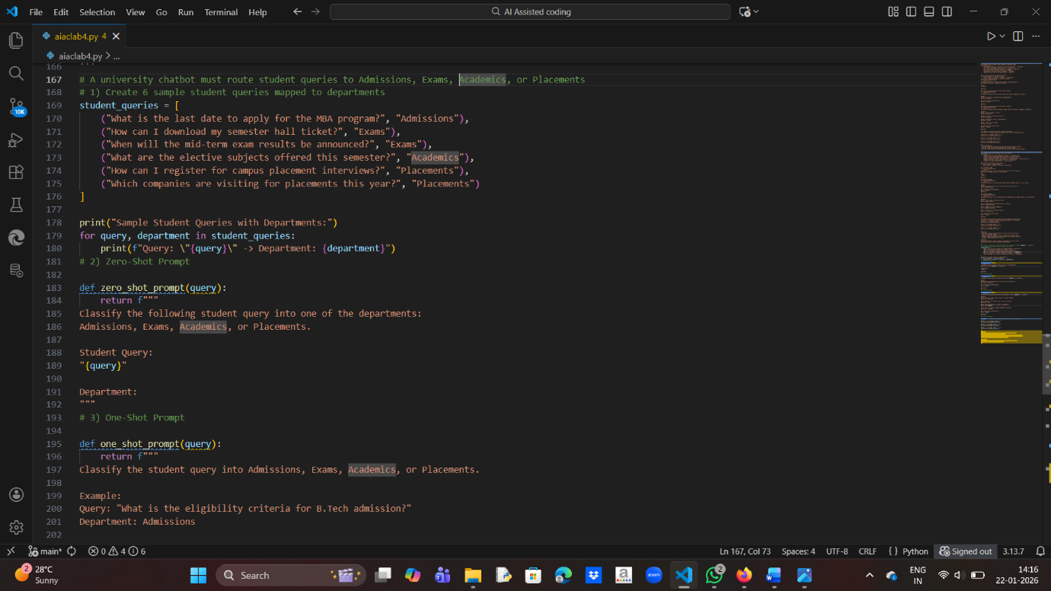

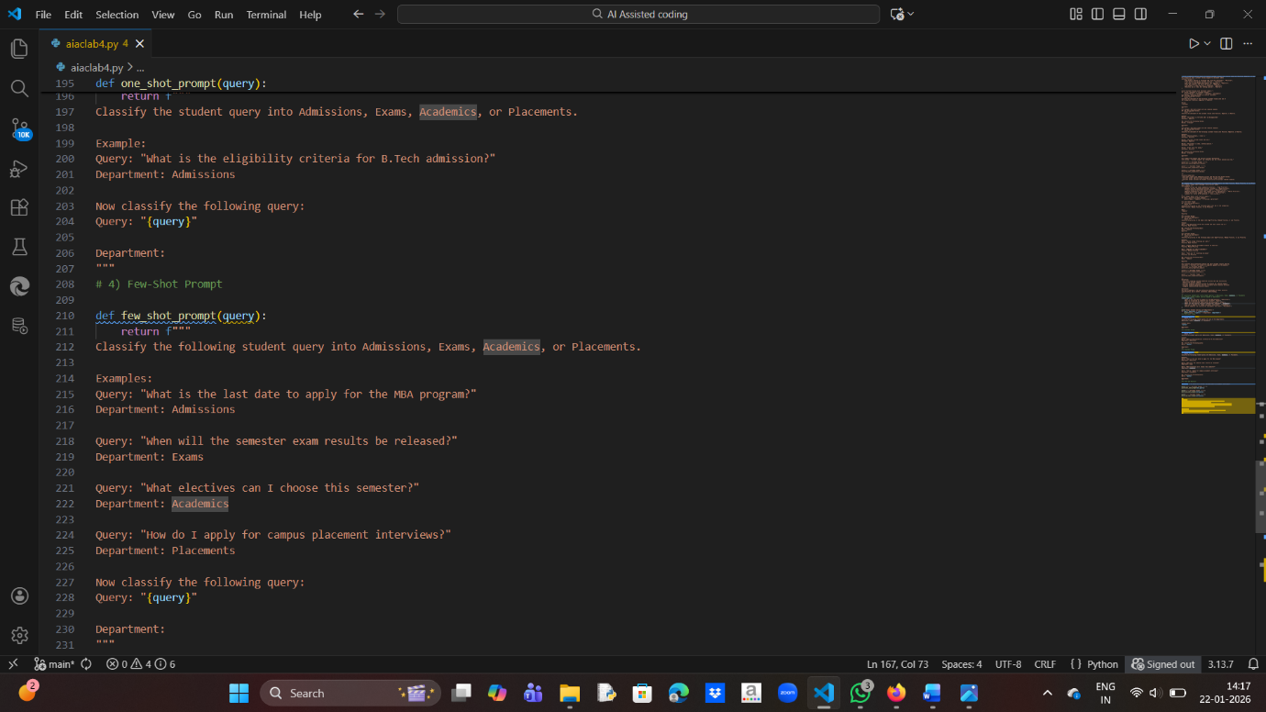

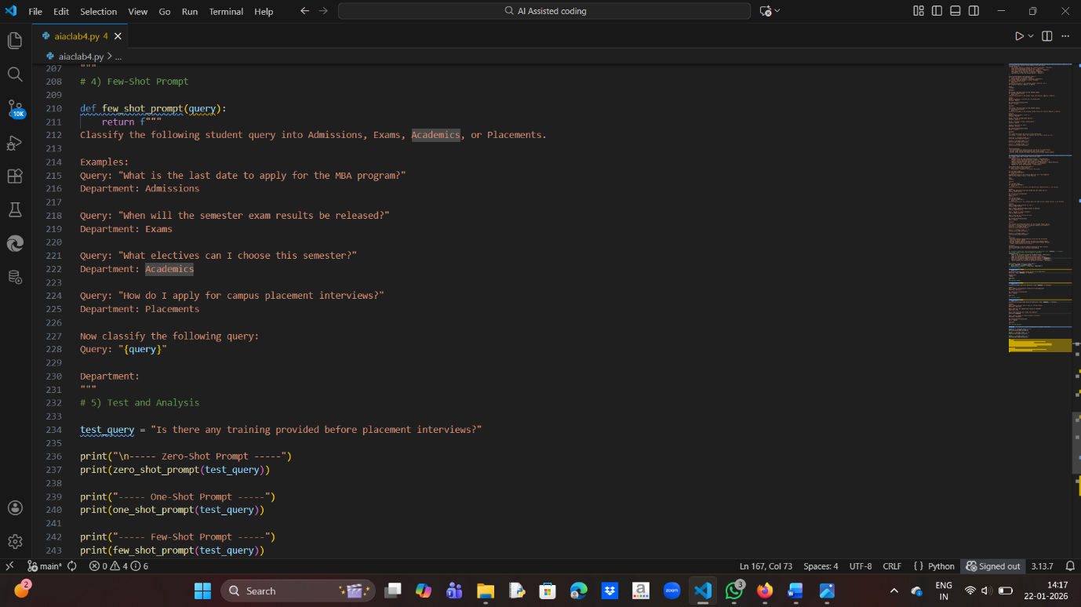

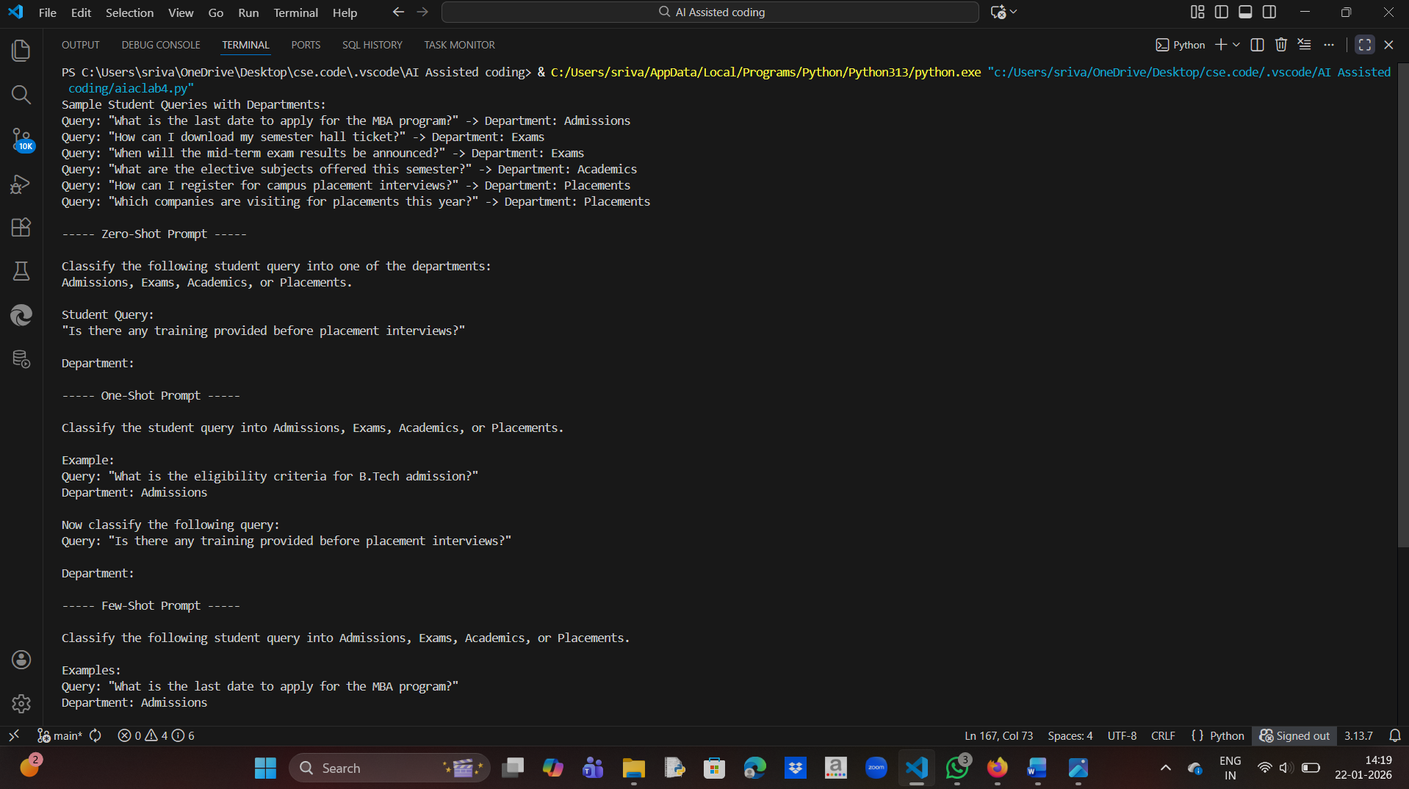

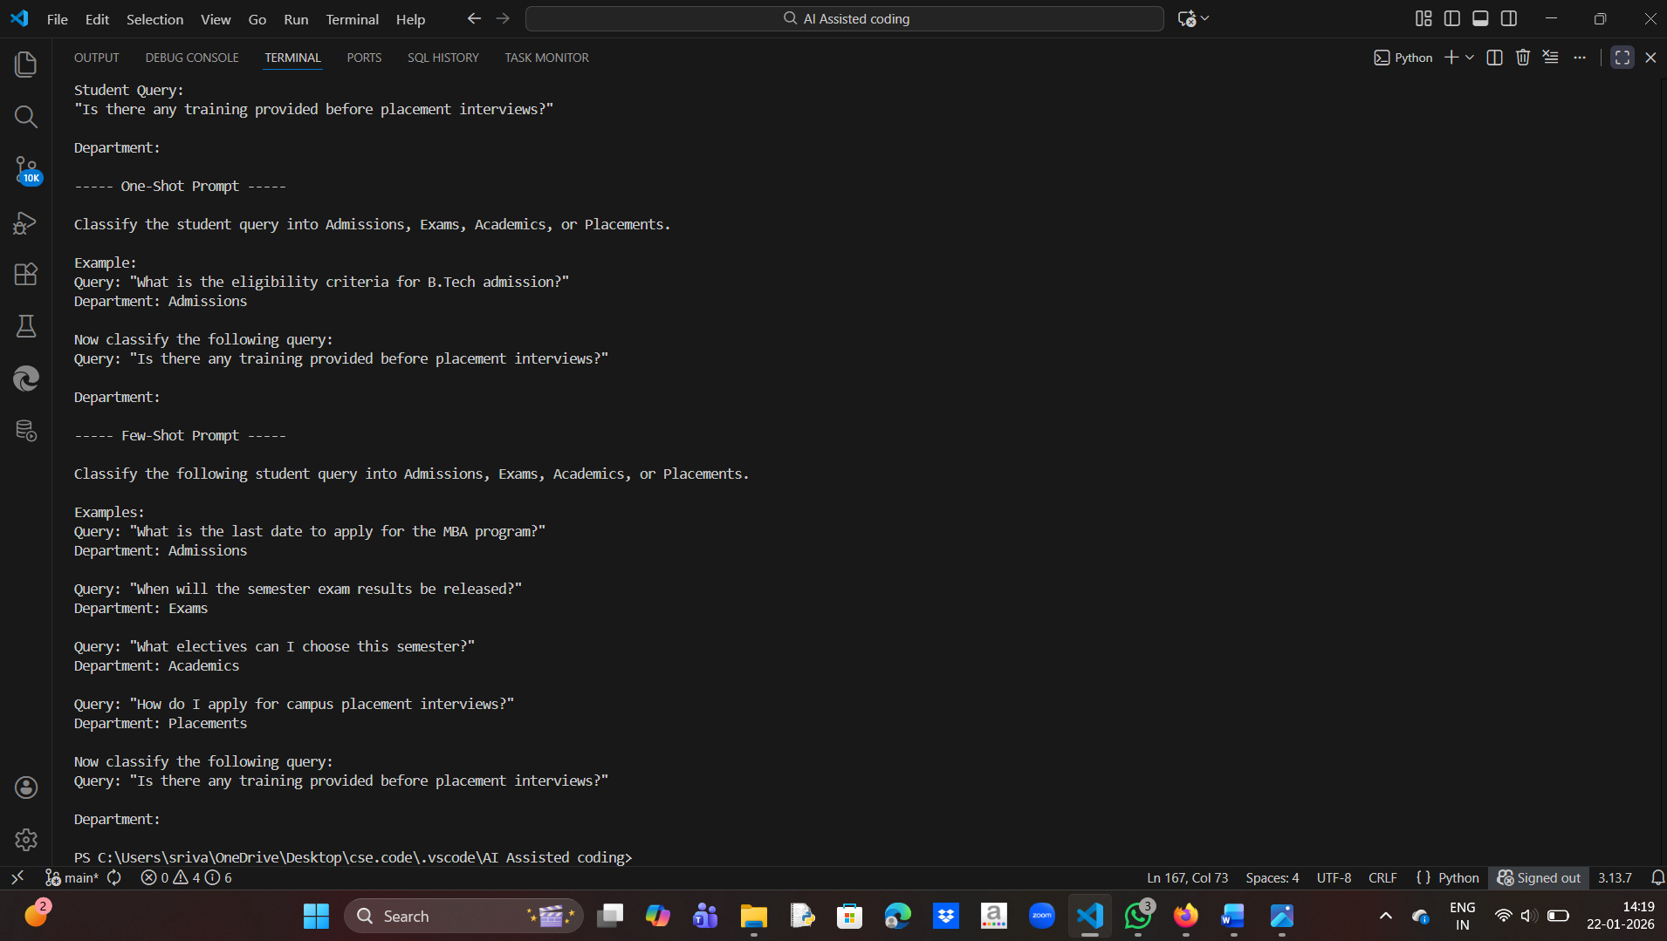

Analysis:

- Zero-shot prompting provides reasonable results but may confuse

  Academics and Placements for mixed queries.

- One-shot prompting improves intent clarity by showing one labeled example.

- Few-shot prompting offers the highest accuracy because multiple contextual examples clearly define each department's scope.

Conclusion:

Providing contextual examples significantly improves classification

accuracy in student query routing systems.

4. Chatbot Question Type Detection

Scenario:

A chatbot must identify whether a user query is Informational,

Transactional, Complaint, or Feedback.

Tasks:

1. Prepare 6 chatbot queries mapped to question types.

2. Design prompts for Zero-shot, One-shot, and Few-shot learning.

3. Test all prompts on the same unseen queries.

4. Compare response correctness and ambiguity handling.

5. Document observations.

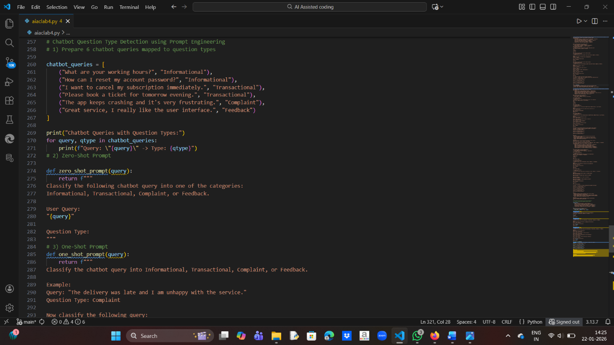

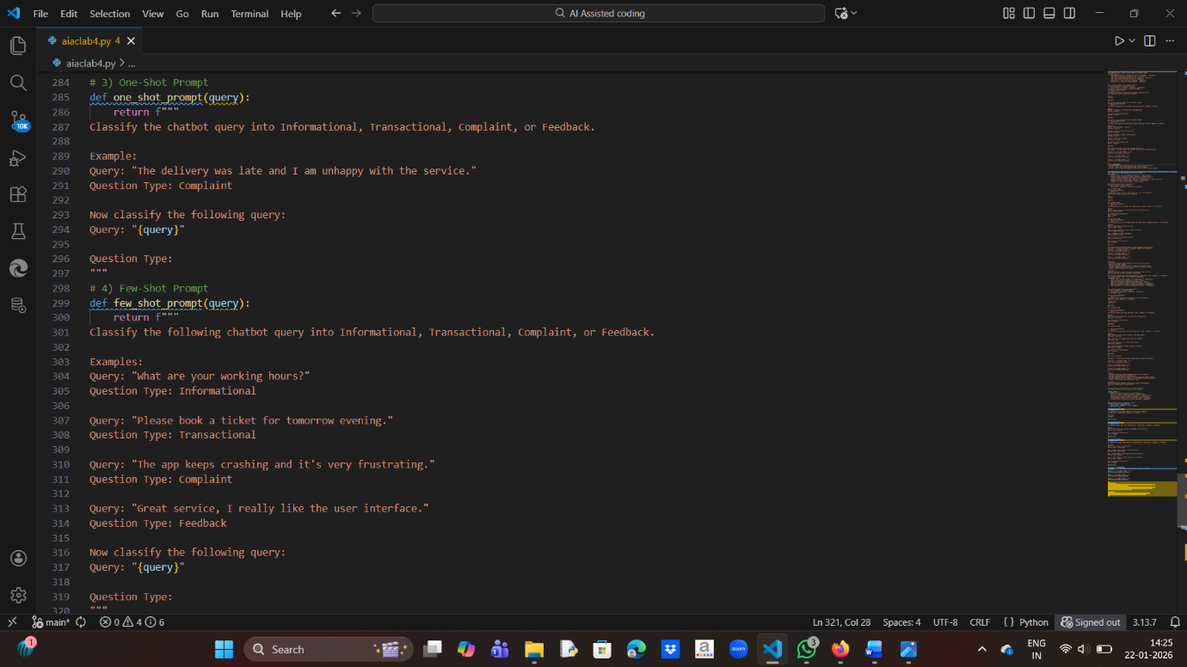

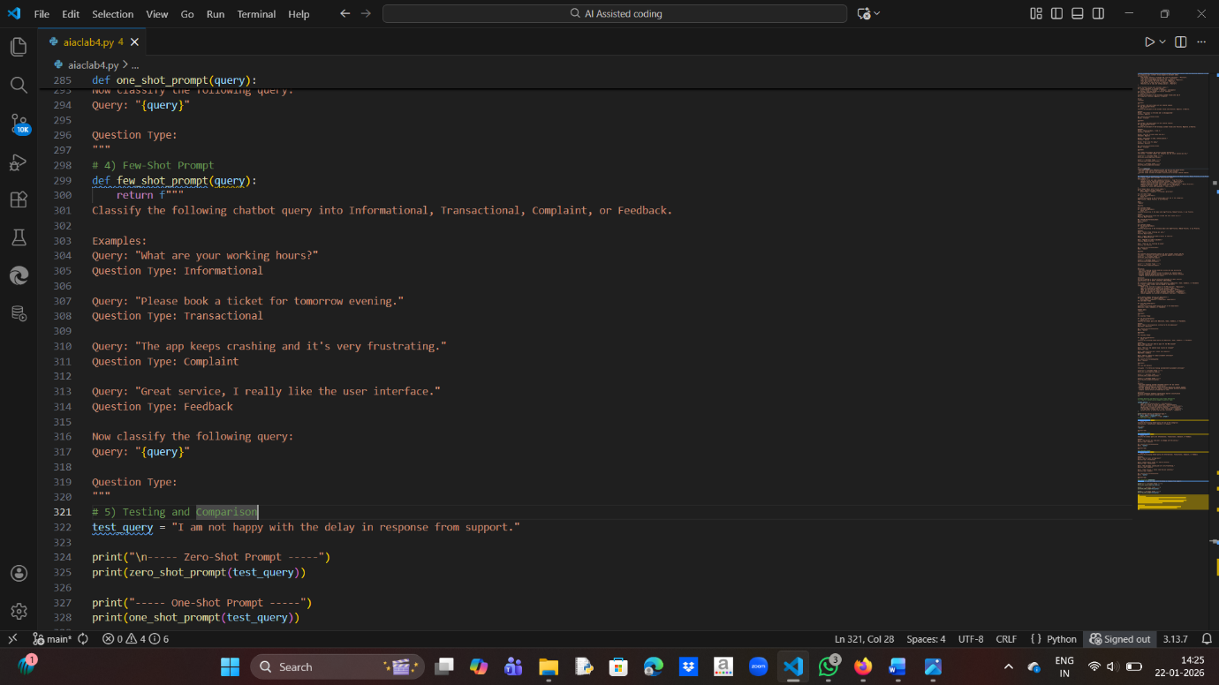

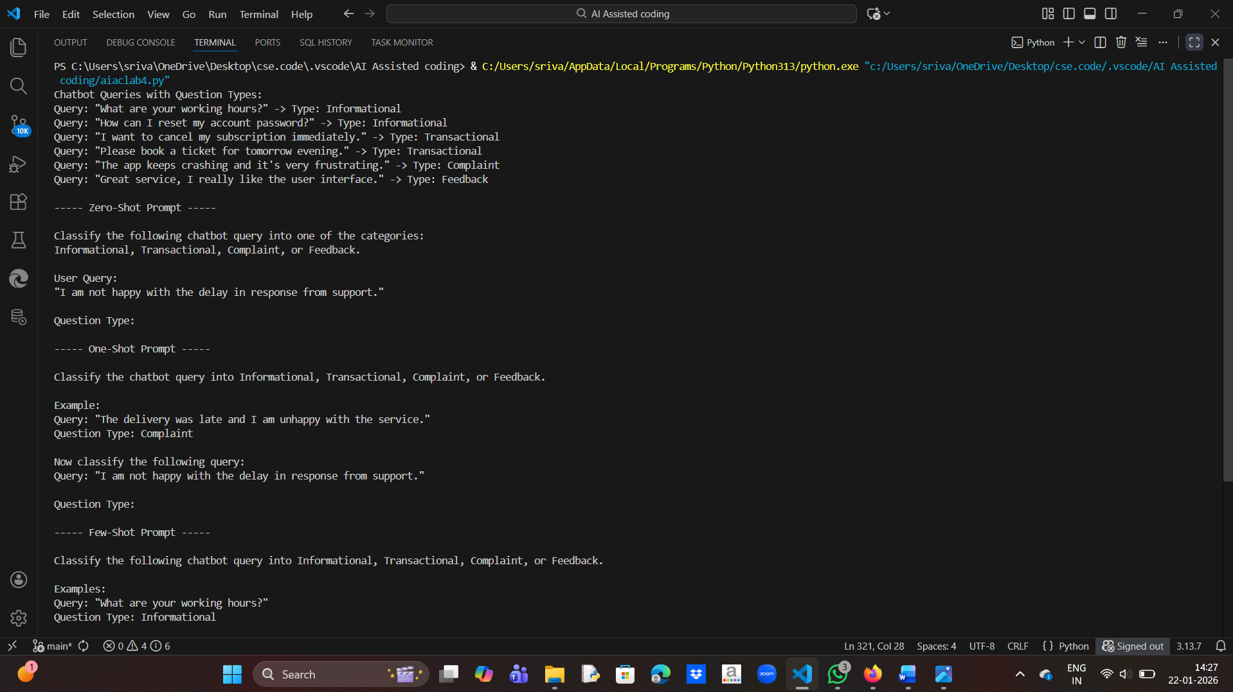

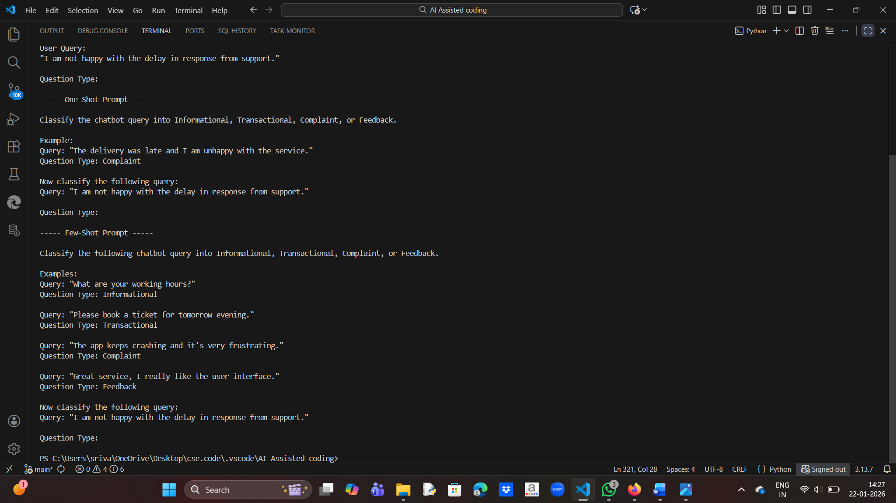

Observations:

- Zero-shot prompting can identify obvious categories but may show ambiguity

  for mixed or emotional queries.

- One-shot prompting improves accuracy by guiding the model with one example.

- Few-shot prompting provides the best performance by reducing ambiguity

  through multiple contextual examples.

Conclusion:

Providing more examples helps the chatbot better distinguish between

informational queries, transactions, complaints, and feedback.

5. Emotion Detection in Text

Scenario:

A mental-health chatbot needs to detect emotions: Happy, Sad, Angry, Anxious, Neutral.

Tasks:

1. Create labeled emotion samples.

2. Use Zero-shot prompting to identify emotions.

3. Use One-shot prompting with an example.

4. Use Few-shot prompting with multiple emotions.

5. Discuss ambiguity handling across techniques.

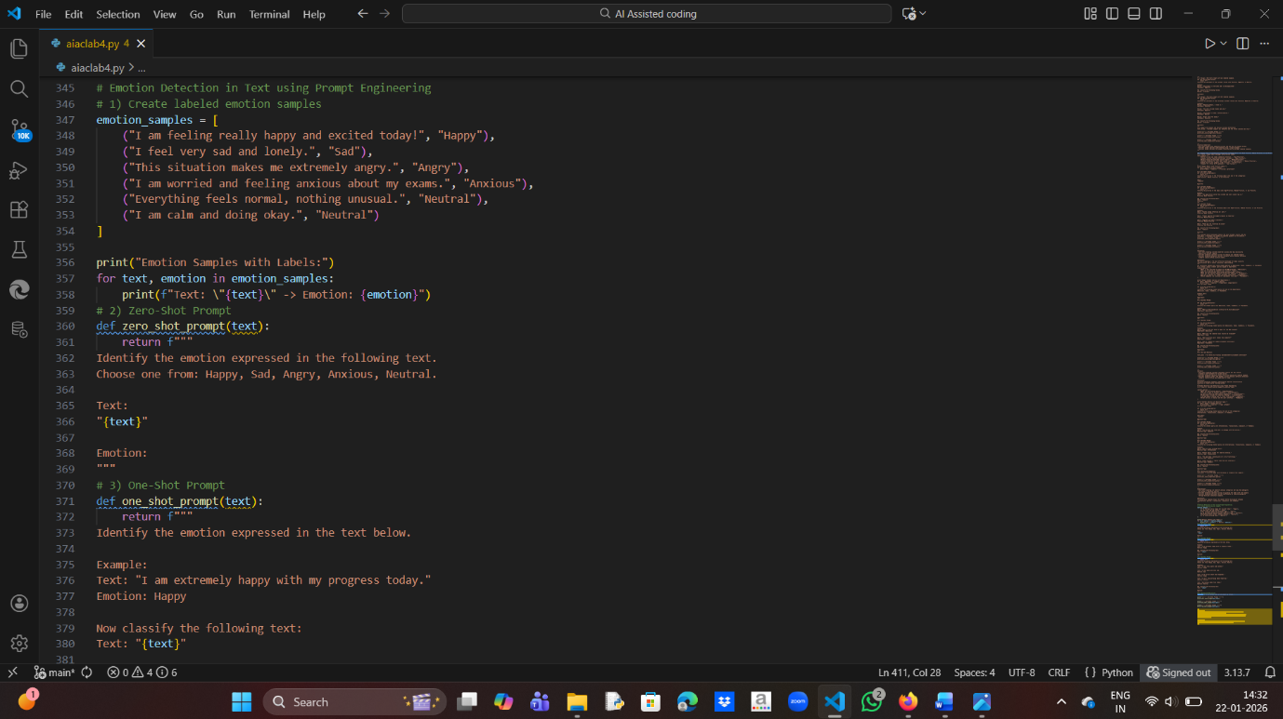

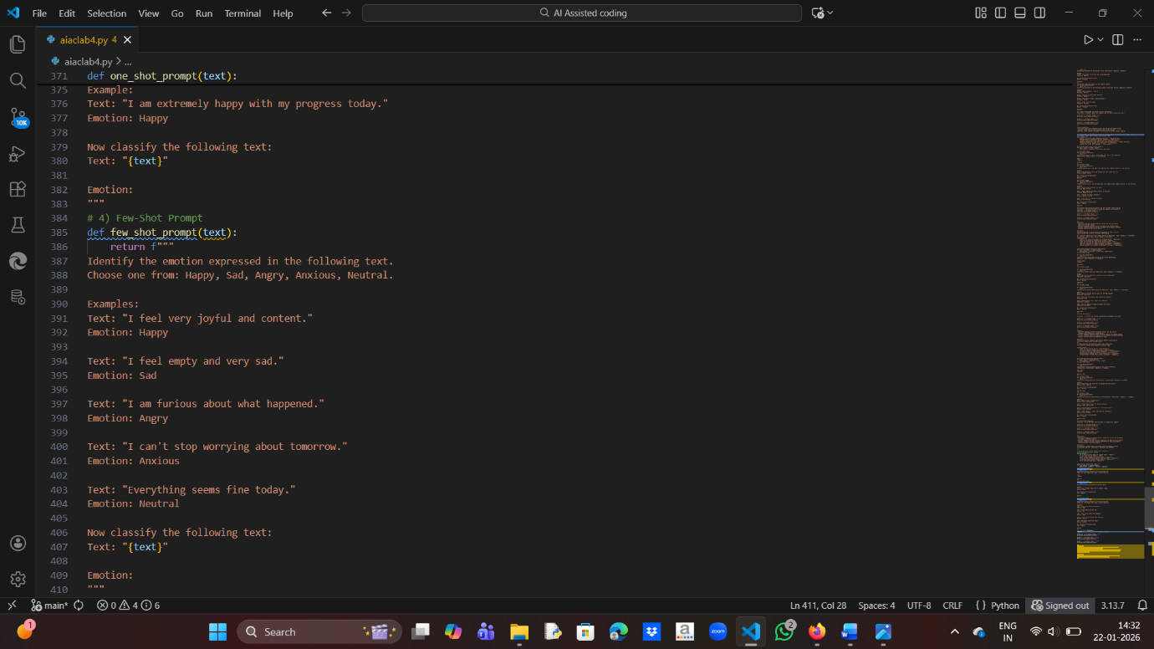

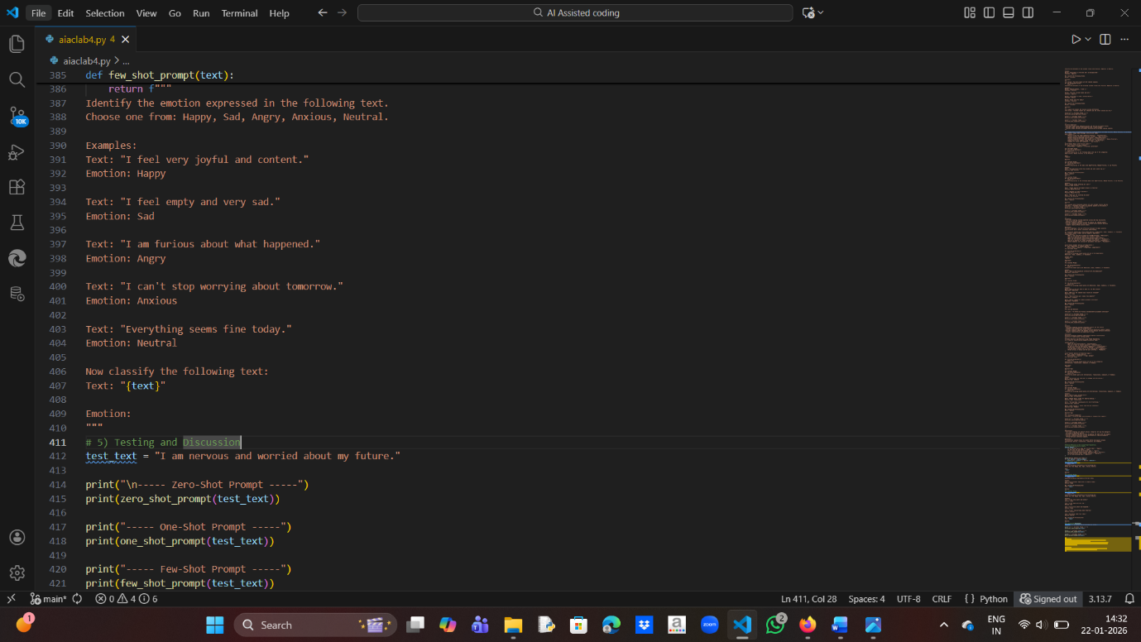

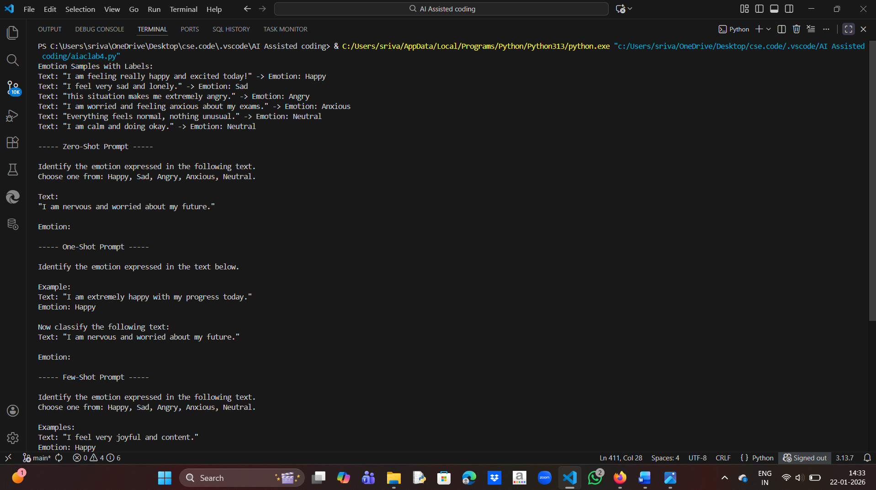

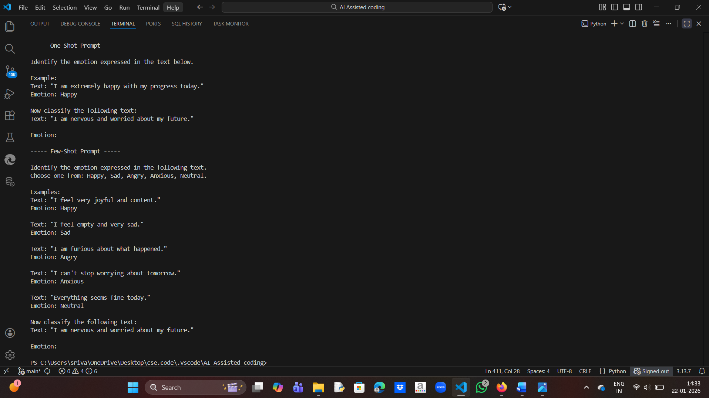

Discussion:

- Zero-shot prompting can detect clear emotions but may struggle with overlapping emotions like anxious vs sad.

- One-shot prompting improves recognition by providing one clear example.

- Few-shot prompting handles ambiguity best by showing multiple emotions and their contexts.

Conclusion:

Few-shot prompting is the most reliable technique for emotion detection in sensitive applications like mental-health chatbots.